**DAILY ONLINE ACTIVITIES SUMMARY**

|  |  |  |  |  |  |  |  |  |
| --- | --- | --- | --- | --- | --- | --- | --- | --- |
| **Date:** | **08-06-2020** | | | | | **Name:** | **Anix Jugal D’Cunha** | |
| **Sem & Sec** | **8 sem , A sec** | | | | | **USN:** | **4AL16CS013** | |
| **Online Test Summary** | | | | | | | | |
| **Subject** | | **SMS** | | | | | | |
| **Max. Marks** | | **60** | | **Score** | | | **60** | |
| **Certification Course Summary** | | | | | | | | |
| **Course** | **Introduction to Data Structures & Algorithms** | | | | | | | |
| **Certificate Provider** | | | **Udemy** | | **Duration** | | | **17 Hours** |
| **Coding Challenges** | | | | | | | | |
| **Problem Statement:** Python Program To Display Powers of 2 Using Anonymous Function | | | | | | | | |
| **Status: Competed** | | | | | | | | |
| **Uploaded the report in Github** | | | | | **yes** | | | |
| **If yes Repository name** | | | | | **alvas-education-foundation/dcunhaanixjugal** | | | |
| **Uploaded the report in slack** | | | | | **yes** | | | |

Online Test Details: (Attach the snapshot and briefly write the report for the same)

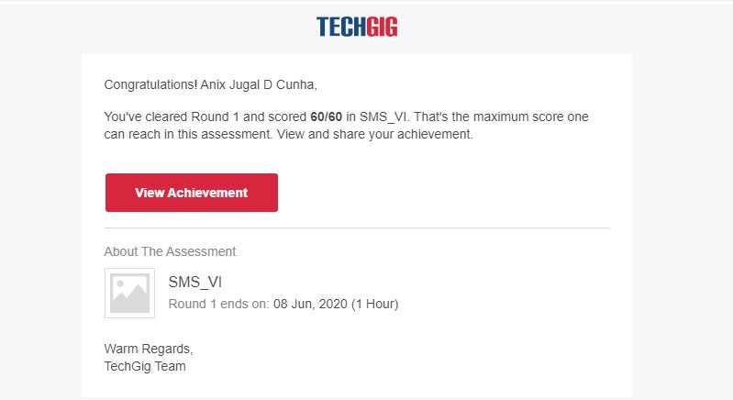

Certification Course Details: (Attach the snapshot and briefly write the report for the same)

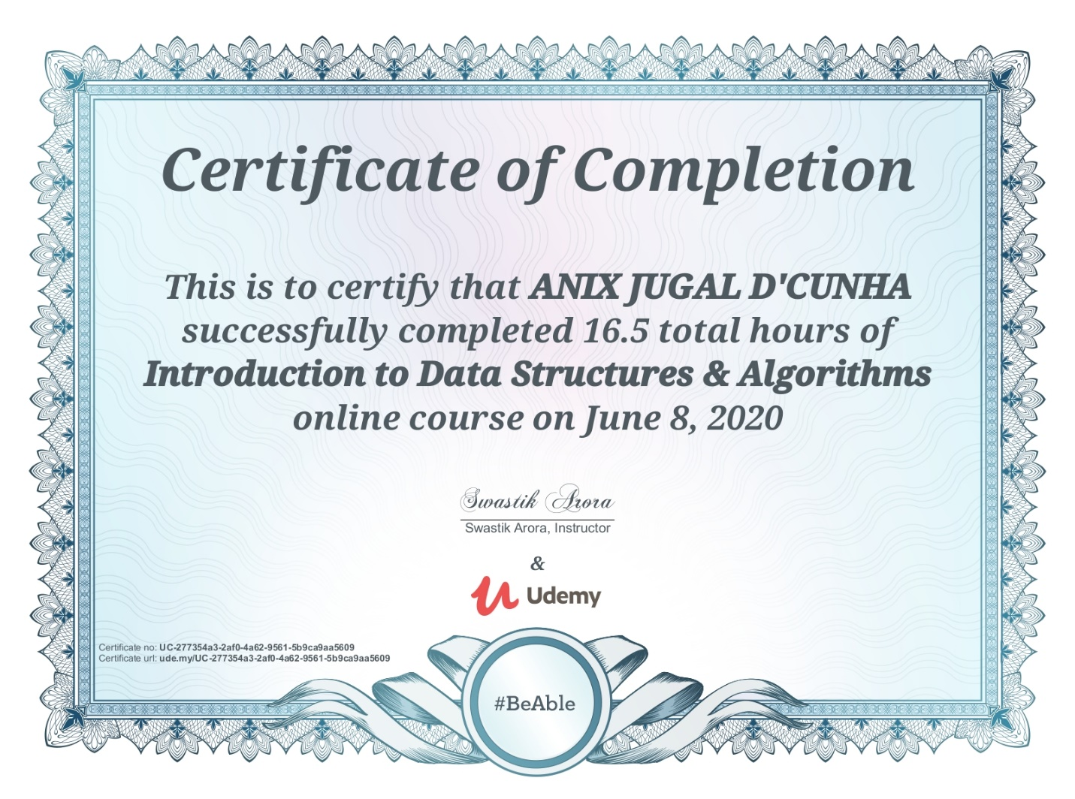

Coding Challenges Details: (Attach the snapshot and briefly write the report for the same)

Program-> Python Program To Display Powers of 2 Using Anonymous Function

# Display the powers of 2 using anonymous function

terms = 10

# Uncomment code below to take input from the user

# terms = int(input("How many terms? "))

# use anonymous function

result = list(map(lambda x: 2 ** x, range(terms)))

print("The total terms are:",terms)

for i in range(terms):

print("2 raised to power",i,"is",result[i])